bootstrap

container

fixed width container

container

full width container

container-fluid

<div class="container-fluid">

<h1>Learning Bootstrap 5</h1>

<p>This is a fixed width container</p>

</div>

Typography

<p class="h1"> h1 Bootstrap heading</p>

<p class="h2"> h2 Bootstrap heading</p>

<p class="h3"> h3 Bootstrap heading</p>

<p class="h4"> h4 Bootstrap heading</p>

<p class="h5"> h5 Bootstrap heading</p>

<p class="h6"> h6 Bootstrap heading</p>

<p class="display-1">Display heading 1</p>

<p class="display-2">Display heading 2</p>

<p class="display-3">Display heading 3</p>

<p class="display-4">Display heading 4</p>

<p class="display-5">Display heading 5</p>

<p class="display-6">Display heading 6</p>

text colors

<p class="text-muted">The text is muted</p>

<p class="text-primary">The text is primary</p>

<p class="text-success">The text is success</p>

<p class="text-info">The text is info</p>

<p class="text-warning">The text is warning</p>

<p class="text-danger">The text is danger</p>

<p class="text-secondary">The text is secondary

<p class="text-white">The text is white</p>

<p class="text-dark">The text is dark</p>

<p class="text-light bg-dark">The text is light</p>

Background colors

<p class="bg-primary">This text is important</p>

<p class="bg-success">This text is success</p>

<p class="bg-danger">This text is danger</p>

<p class="bg-warning">This text is warning</p>

Row and column classes

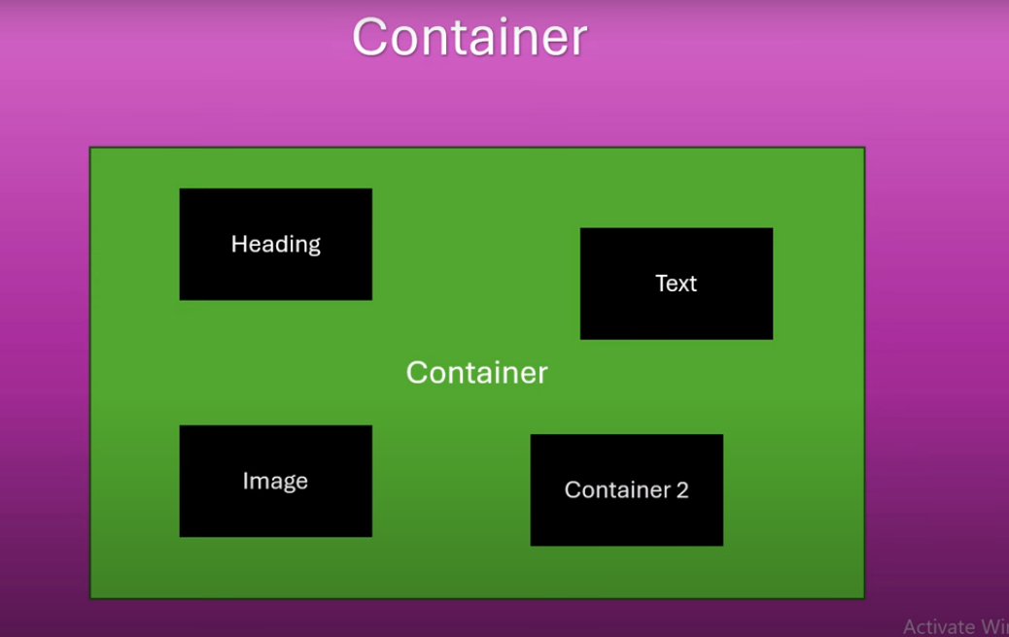

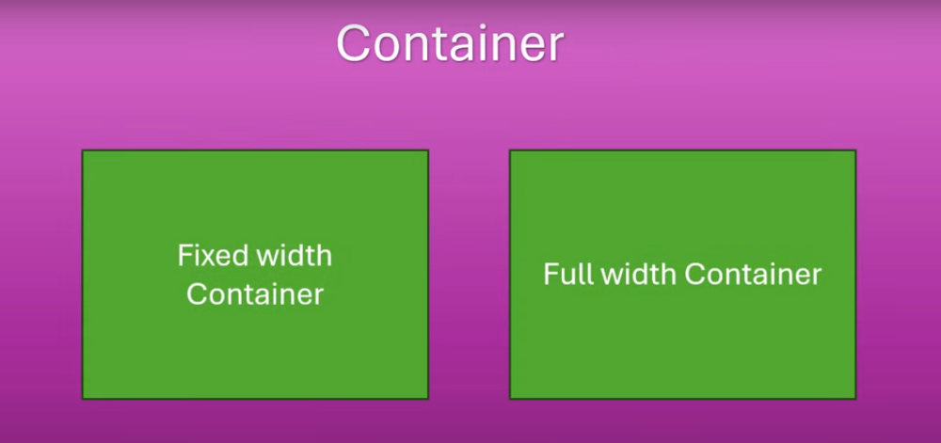

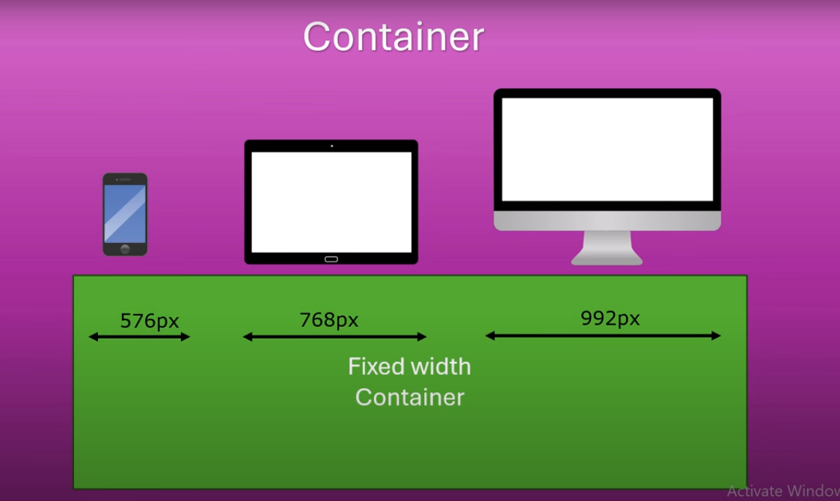

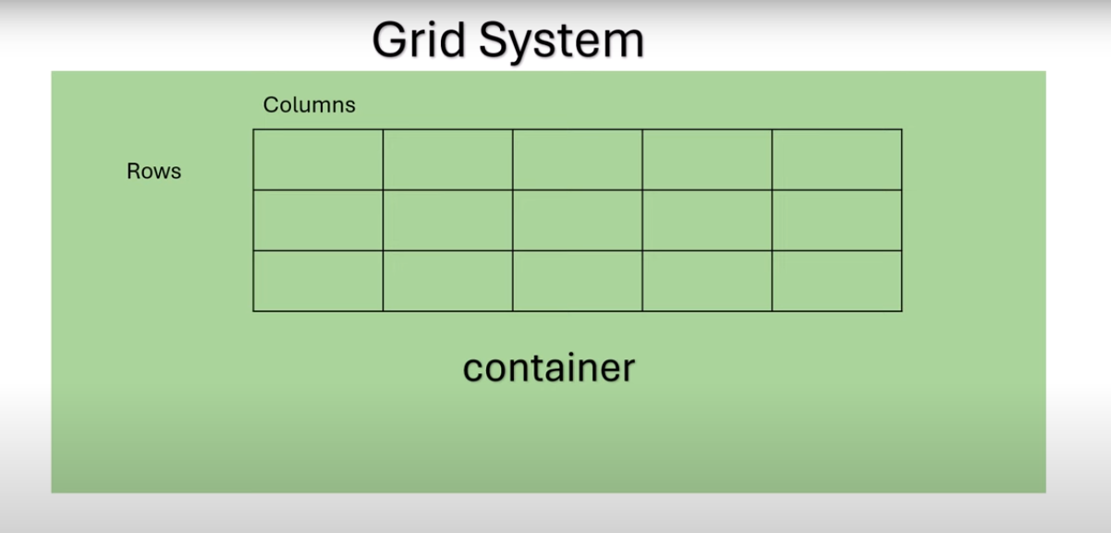

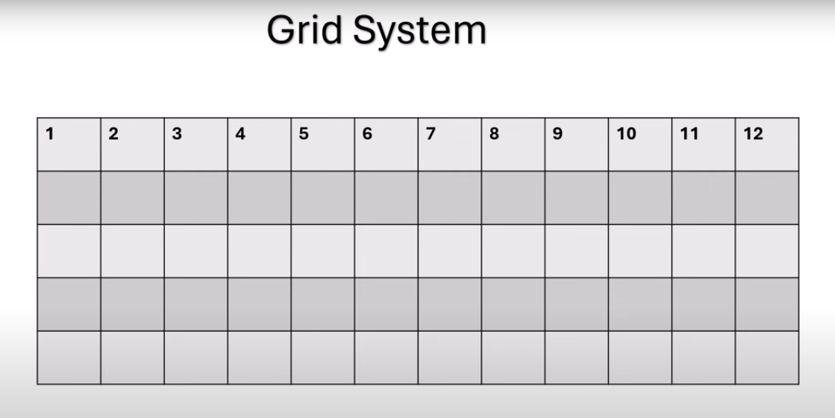

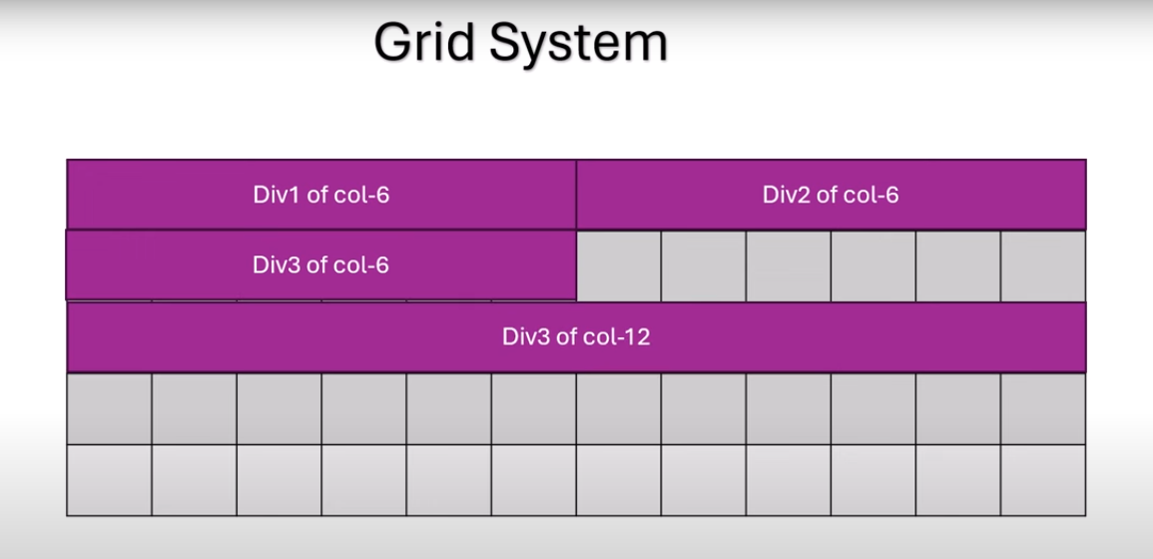

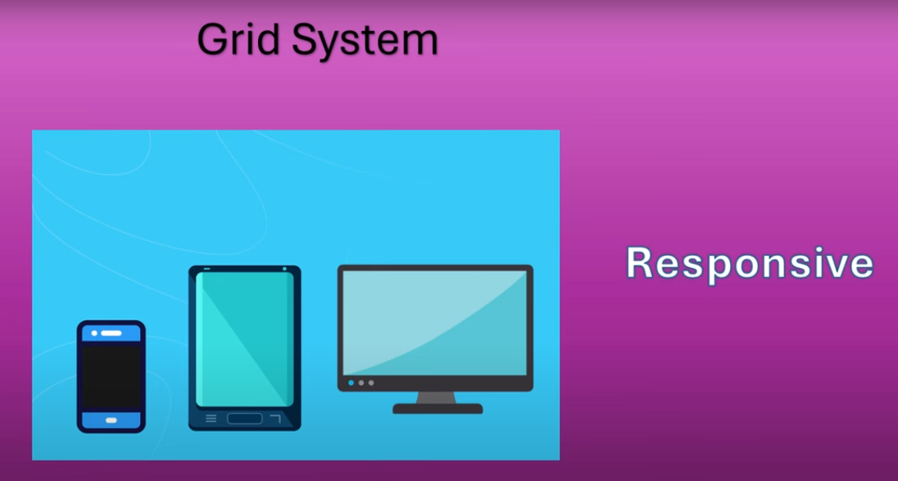

<div class="container">

        <!-- Content -->

       <div class="row">

          <div class="col">

            <p>This is a simple column in row</p>

          </div>

          <div class="col">

            <p>This is a simple collumn in row</p>|

            </div>

<div class="col">

<p>This is a simple column in row</p>

</div>

       </div>

    </div>

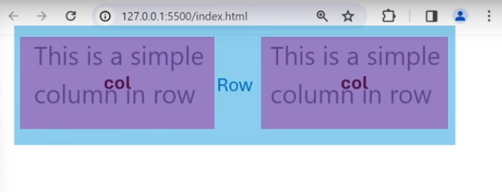

Simple Blog layout

Padding

<header class="px-4"> it wont add space for top and bottom

<header class="py-4"> I wont add space for left and right

<header class="ps-3"> s means start

<header class="pe-3">e means end

Margin

Responsive columns

<div class="container pt-3 pb-4"> <!--pt-padding top,pb-padding bottom-->

        <h1 class="mb-5">Simple Blog with Bootstrap 5</h1>

        <div class="row mb-3">

            <div class="col-12 col-md-4">

                <h2 class="mb-3">Post Title 1</h2>

                <p>Date: Feb 15, 2024</p>

                <p>This is the content of Post 1</p>

            </div>

            <div class="col-12 col-md-4">

                <h2 class="mb-3">Post Title 2</h2>

                <p>Date: Feb 16, 2024</p>

                <p>This is the content of Post 2</p>

            </div>

            <div class="col-12 col-md-4">

                <h2 class="mb-3">Post Title 3</h2>

                <p>Date: Feb 17, 2024</p>

                <p>This is the content of Post 3</p>

            </div>

            <div class="col-12 col-md-4">

                <h2 class="mb-3">Post Title 4</h2>

                <p>Date: Feb 15, 2024</p>

                <p>This is the content of Post 1</p>

            </div>

            <div class="col-12 col-md-4">

                <h2 class="mb-3">Post Title 5</h2>

                <p>Date: Feb 16, 2024</p>

                <p>This is the content of Post 2</p>

            </div>

            <div class="col-12 col-md-4">

                <h2 class="mb-3">Post Title 6</h2>

                <p>Date: Feb 17, 2024</p>

                <p>This is the content of Post 3</p>

            </div>

         </div>

    </div>